(Approx. 1194 words)

Notes
By Dick Maybach, Brookdale Computer User Group
www.bcug.com
n2nd (at) att.net

Almost every day, I make, edit, and refer to notes of three types:
- instructions for complex procedures — configuring operating systems and editing photos,
- lists — repair parts, frequent user IDs, groceries, and
- drafts for articles such as this one.

Since nobody else sees these, spelling and grammar aren't important, but I quickly find what I need and make changes. Over the years, I've tried and discarded several methods of collecting such information.
- Paper notes are quick but easily misplaced and difficult to keep current.
- A word processor is an overkill.
- A text editor is simpler, but like a word processor, it leaves you organizing the information.
- Screenshots are easily lost if you aren't extraordinarily disciplined in choosing filenames and organizing directories.

Most of my complex procedures occur at my PC, as does work on drafts. My preferred solution here is a notes program, which organizes minimally formatted text and allows inserting images. There are dozens available, but I suggest Windows users consider OneNote Microsoft OneNote tutorial: Everything you need to know to start taking notes | PCWorld An alternative is to use CherryTree, cherrytree – giuspen

Usually, I need my lists away from home, meaning they should reside on my cell phone. OneNote can be used here, too; it's more complex than necessary, but having the same application on both platforms is an advantage. An alternative is Monospace on Android. Let's take a brief look at these programs before discussing how to use them.

Windows 10 comes with the notes program OneNote, Figure 1, which copies its data to a Microsoft cloud server for synchronizing with your other PCs as well as your cell phone. It stores not only text but also images, hand-drawn sketches, links, and websites. As you can see from the menu bar, it offers the usual formatting (font size and styles, and lists). You can enter text from the keyboard or by using dictation.

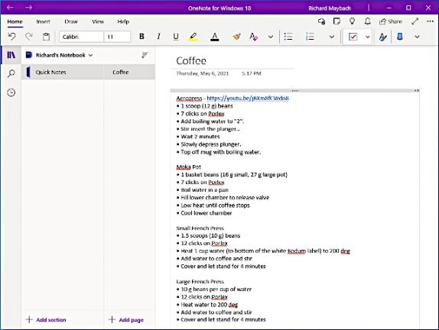

Figure 1. Windows OneNote.

Figure 2 shows the same note, but as viewed by the Android OneNote app.

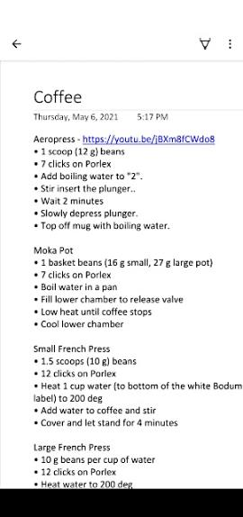

Figure 2. Android OneNote App.

Notes programs are not suitable for sensitive data, such as passwords. Instead, use a program that stores data in an encrypted database, such as KeePassXC, available for PCs and cell phones at https://keepassxc.org/. This is especially true when the data is stored in the cloud. If you are concerned about privacy, OneNote allows disabling its sharing feature.

CherryTree, Figure 3, is an alternative to OneNote for Windows and Linux users. It has fewer features than OneNote; in particular, it doesn't allow automatic sharing, voice dictation, hand-drawn sketching, or including web pages (although you can insert links). However, it does allow exporting its content as text, PDF, or HTML files, which OneNote doesn't (although you, of course, can copy and paste the content of both).

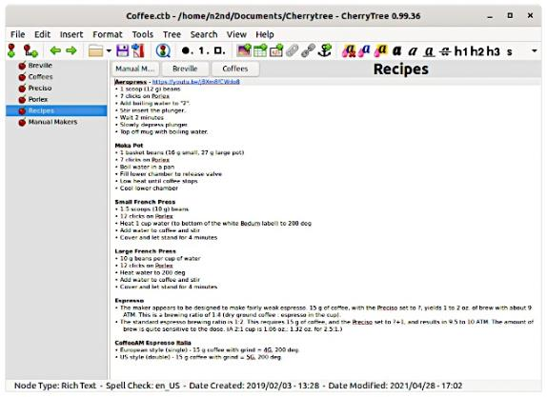

Figure 3. Cherry Tree.

CherryTree has no Android equivalent, and I use Monospace, Figure 4, for Android notes. Using CherryTree and Monospace means you must explicitly transfer data between your PC and your cell phone, which can be an advantage or disadvantage depending on your attitude about privacy. The process is to export a note from CherryTree as a text file, do some minor editing, and then copy it to the MonoSpace directory on your cell phone. While it would be convenient to have all my notes mirrored on my cellphone, it isn't essential. I seldom need to access the notes on my PC from my cellphone and visa versa, although I copy the Monospace directory to my PC for backup.

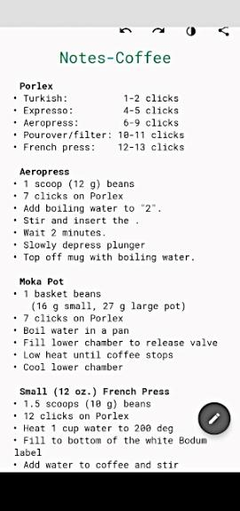

Figure 4. Android Monospace App.

A key to using notes efficiently is to keep them organized. For example, I use separate files (think notebooks) for my major topics. Figure 5 shows my recently-used notes files on a drop-down menu from the Files menu item, which allows changing topics with just a couple of clicks. (I'm showing CherryTree examples, but OneNote behaves similarly.)

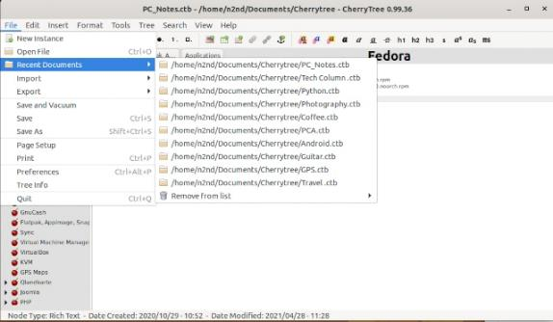

Figure 5. Recently Opened Notes Files.

The individual notes in each file are organized as hierarchical tables; for example, Figure 6 shows a page of the CherryTree manual.

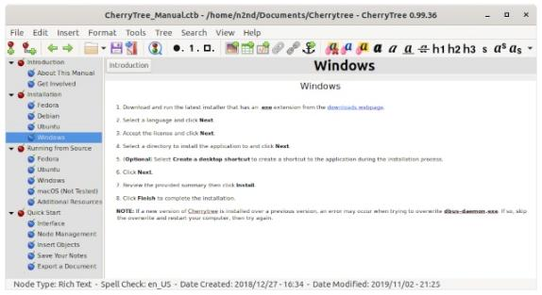

Figure 6. CherryTree Note Page.

You must exercise discipline to make the tool effective for notes on complex tasks. Look over your notes each time you reference them to correct errors and accommodate changes, especially when working with software, as programs evolve quickly. Be especially vigilant about deleting obsolete information. I seldom read a note without finding something that is outdated or just wrong.

Notes can become quite lengthy, as you can see in Figure 7, which shows a portion of my note on PC configuration. The left panel shows only about half of the topics, and the right panel shows just a fraction of the installation note.

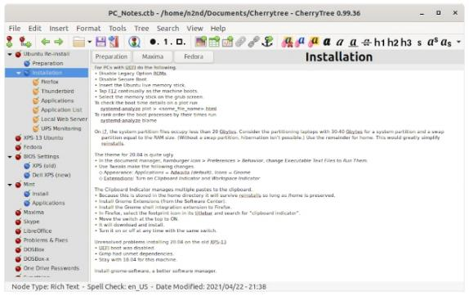

Figure 7. A Complex Note.

It's easy to fool yourself when you capture a website or a screenshot. Not only can it mislead you into thinking you understand something, but by consuming so much space, it can make it challenging to find information. On the other hand, abstracting what you've seen not only increases the likelihood that you understand it but also takes far less space.

Keep in mind how you will access the information when you need it. For example, your note on repairing your network won't be available if your network is down and stored in the cloud. Similarly, your note on how to recover a lost PC password won't be available if it's stored on that PC.

I work in a different mode when assembling material for a document, as the purpose of such notes is only to collect information. Here, I freely collect screenshots and websites without regard for the resulting clutter, as the note will be deleted when the document is complete. (Years ago, a writing instructor referred to this phase as "garbage down.”) I don't worry about spelling, grammar, or style, as the goal is to capture what I learn before I forget it. Once I have the information, I transfer everything to a word processor, where I do the organizing. This ensures I don't prematurely delete source material. Once the article is complete, the note can be deleted. Figure 8 shows a portion of the note I used while developing this article.

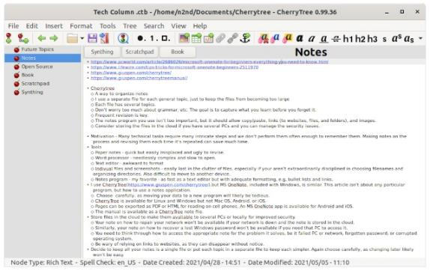

Figure 8. Temporary Note for a Tech Article.

My lists are much simpler than the two sorts of notes above, and I most often use them on my cell phone. (I need my shopping list when I'm in the store, not while sitting at my PC.) However, it's important that you can transfer these to and from your PC, as cell phones are vulnerable. Losing a shopping list isn't that inconvenient, but losing your list of replacement parts for home repairs could be. Some years ago, I had an Apple digital assistant, and when I changed to an Android one, I had to enter all the note data by hand. They were stored on the PC in a proprietary format and readable only on the Apple device.

I've found notes programs to be invaluable in keeping both my complex and my simple tasks organized. I recommend you give one a try.

